**In class Programming Assignment -7**

**GitHub Link: <https://github.com/poojasrinivas29/icp7>**

**Video Link:https://drive.google.com/file/d/1x0Y3sk-Y5nmL9Lo4AcVBl4JNNyh1uYxl/view?usp=sharing**

**Problem 1:** Basics of LSTM, Types of RNN, Sentiment Analysis on the Twitter data set

**Solution:**

1. Saving the model and using the saved model to predict on new text data.

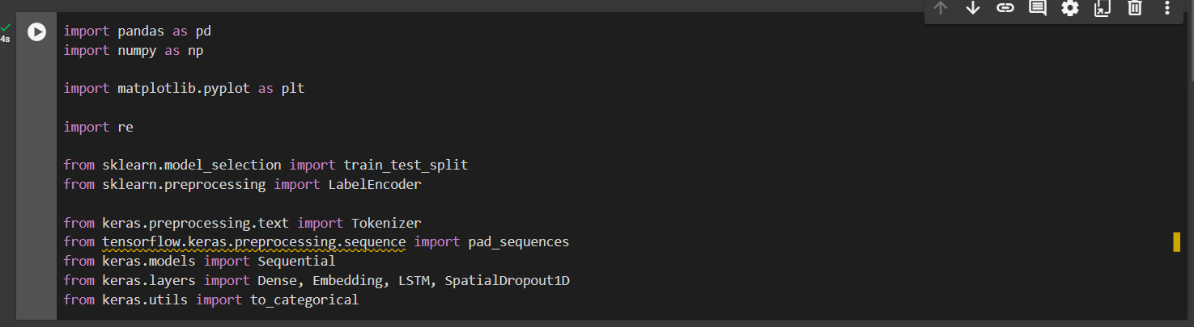

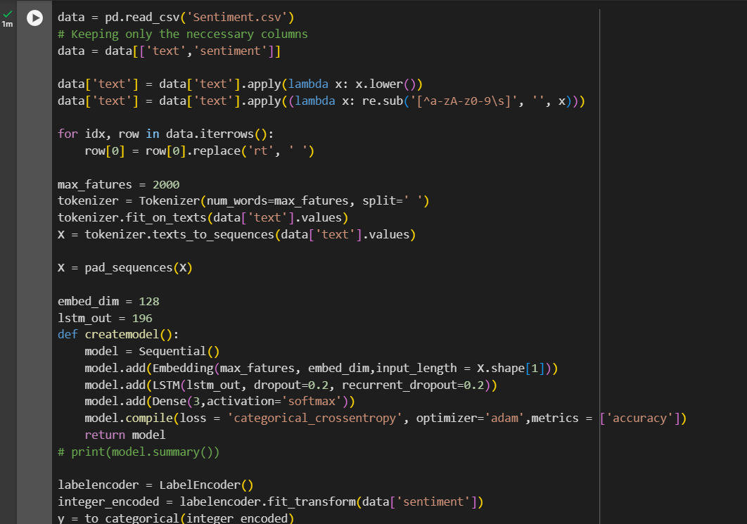

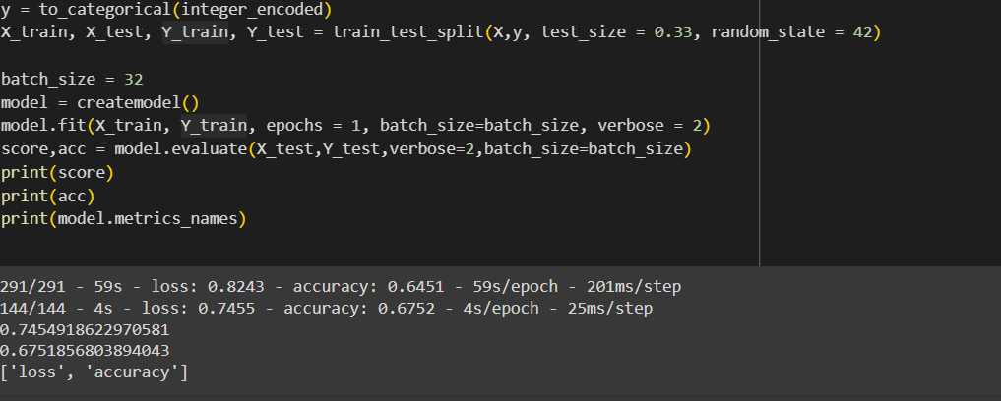





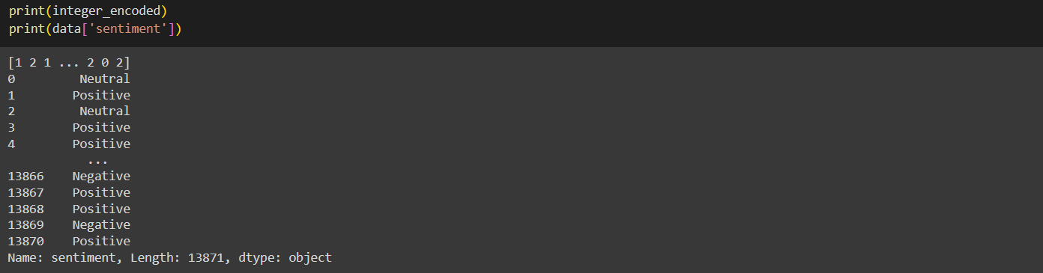

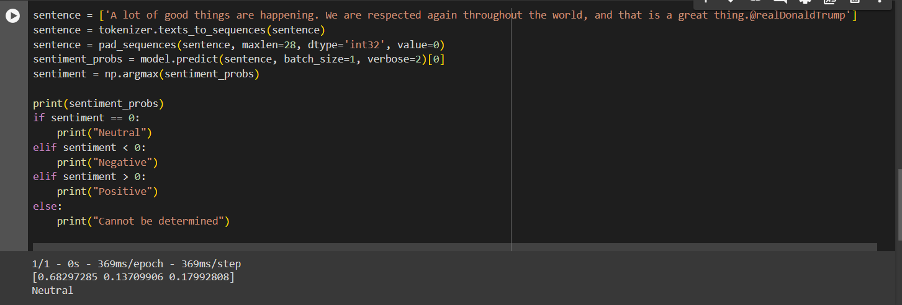

1. Applying GridSearchCV on the source code provided in the class.



